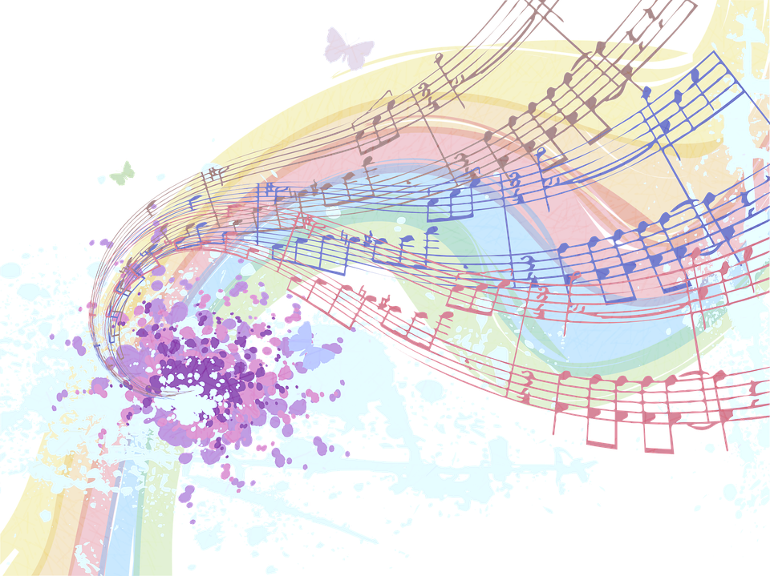
Here are our Spotify playlists from previous dance parties:

Spanish Family Dance Party

Animal Family Dance Party

Hat Day Family Dance Party

Silly Family Dance Party

https://open.spotify.com/playlist/3ibqwcOuDq4KxQjo1HYtOq?si=-SmdoaLqRbCcbHy_1ETkvA

https://open.spotify.com/playlist/3B4GMzmfrm3NH4XVeLHIq3?si=rbvofW68StebouLG6aBhUw

https://open.spotify.com/playlist/6QR1SVVA6HPi41mgVx4pjp?si=5N0OjLXDT8WbS8TyByA8cw

https://open.spotify.com/playlist/3G7qjnCtNvIi93bVF1a49b?si=dd0kyQzKRrK1ld9ztWTe4g

https://open.spotify.com/playlist/6ZLR3FDHBDFaHiNbgthE8l?si=eSKL_lW_Q1uqGL4R9CaJkA

https://open.spotify.com/playlist/1jdripIeuOlHwWnTYWTxrY?si=DSglj57zRlOWHjtYf3gaHA

https://open.spotify.com/playlist/3WvK3hraSuB3HP0hfFaaxz?si=_ce2nNL6Tt-AFWg3BkP7zA

https://open.spotify.com/playlist/3z9N8SLtIxJ4HOzSJs9IzT?si=ybiV1YDiTiSAsZPvuyQDlA

